Overflow
AP Computer Science Principles Name___KEY___

Visit the Code.org odometer widget at https://studio.code.org/s/odometer/stage/1/puzzle/1Press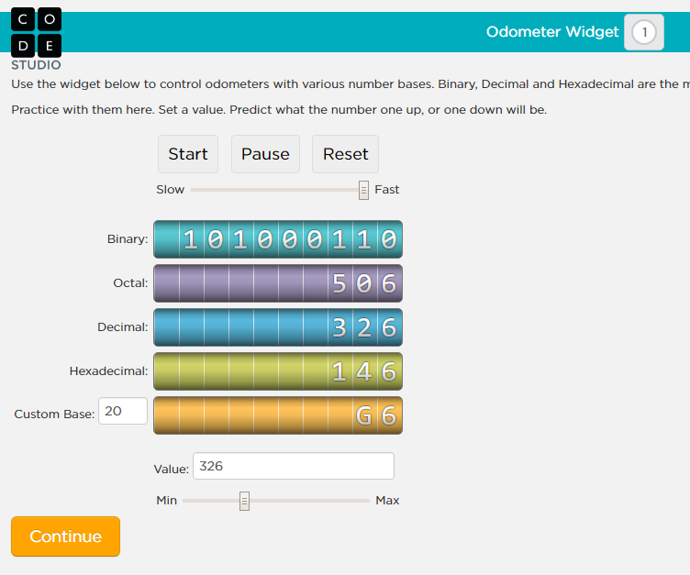
Press Start and experiment with Slow Fast and Min Max controls. Write your answers to the following questions in the provided blanks.

How many bits are in the binary odometer? ___10________

What is the largest value the binary odometer can hold before it overflows?

__1111111111__

What is the decimal value of that largest binary number? ___1023_____
Type the decimal value of your answer to #2 in the Value field. Now increase that number by one. What binary number is now displayed in the binary odometer?

___0000000000___

Computers use a fixed amount of bits to store numbers. This creates a vulnerability to an error called overflow. If a value increases enough, it will be too large for the number of bits and will reset much like a car odometer. Java uses a signed 32 bit system to store integers. Basically, 1 bit is used to store whether the number is positive or negative and the remaining 31 bits are used to store the number’s value.
Signed Integer Bit Size Range of values that can be stored
16 bits (2 bytes) −32768 to 32767
32 bits (4 bytes) −2,147,483,648 to 2,147,483,647
64 bits (8 bytes) -9,223,372,036,854,775,808 to
9,223,372,036,854,755,807

Start the Processing program. Make sure you are in Java mode. Type the code shown and press the play button. You should a screen similar to the one below:
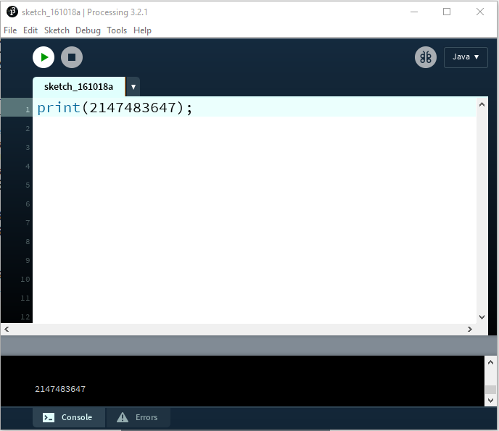
Now modify your program as shown below and press play.
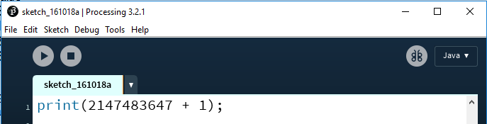
Did the program display the correct result of adding 1 to 2147483647? Write the number

that was displayed here____−2147483648____. If you look back up at the top of this worksheet, can you find that number you just wrote in the blank? Notice that this is overflow. Adding one to the largest value an Java integer can hold results in it resetting to the smallest value it can hold. Try experimenting by changing the 1 to different values. Is it possible to add a positive value to 2147483647 that gives a result of 0? Why or why not?

______________No, Java will not let you add a number larger than 2147483647____

Underflow is a similar problem. Underflow is when a variable is decreased below the minimum value for that type. Write some Java code that would create an underflow below:

print(-2147483648 - 1);

Complete the following questions:

1. What is the largest number that could be stored using 5 bits? (One way to find the answer is to type 5 ones in binary mode on the Windows calculator)
31

2. What would be the result of adding the decimal numbers 31 and 1 in a 5 bit system?
0

3. What would be the result of adding the binary numbers 10000 and 10000 in a 5 bit system?
0

4. What is the largest number that could be stored using 8 bits?
255

5. What would be the result of adding the decimal numbers 220 and 40 in an 8 bit system?
4

6. The original Donkey Kong game has a number in the top right-hand corner of the screen which counts down as the game is played. This is the bonus counter. Fail to complete the level before the bonus counter hits zero, and Mario keels over and dies.

The original Donkey Kong used an 8 bit system to store the bonus counter. The bonus counter value was calculated by multiplying the level number by 10 and adding 40. The game has a bug on level 22 where Mario suddenly keels over and dies, with no obvious injury from a rolling barrel or any other nearby hazard. It’s a bug that, regardless of how good the player is, always ends the game in exactly the same place. Why does Donkey Kong always break on level 22? Overflow causes the bonus counter to start at 4 on Level 22
(You can read the story of the Donkey Kong level 22 bug at http://mentalfloss.com/uk/games/31376/why-does-donkey-kong-break-on-level-22)

